
CC-215-L: Database Systems Lab
Faculty of Computing & Information Technology

BS(IT&CS) Morning - Fall 2023
LAB – 05
The objective of this lab is to:
- Revise Previous Content
- Practice Joins
- Basic Subqueries
Course & Lab Instructor: Dr. Asif Sohail
Task 01: [10 Marks]
- Write an SQL query to retrieve employees whose salaries do not fall within the ranges specified in the salgrade table. Display their grade as “F”.
- Display the employees who earn less than their subordinates.
- Generate a report of the maximum salaries earned in all departments. Also display the sum of these salaries.
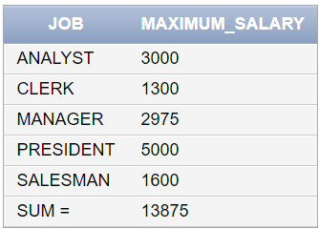
- List all the employees who have the same salary grade as their manager. (Use of “Join” keyword is not allowed)
- List all the employees with their subordinates in the following format.
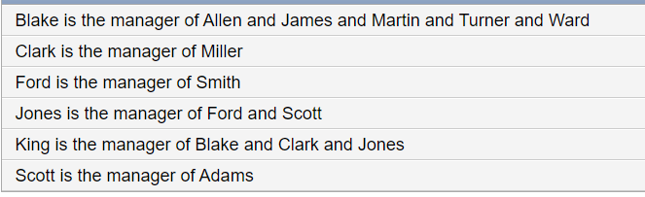
- Query to find employees who earn more than the average salary of their department.
- Display department names and the total number of employees. Output should be as follows:
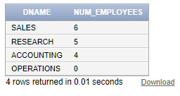
- List all employees who have a salary greater than the average salary across all employees, but less than the highest salary in their department.
- List the employees who work in the same department as an employee with the job title 'MANAGER' but are not themselves managers.
- Retrieve the names of the employee who earn the lowest salary but also receive a commission.
Task 02: [16 Marks]
- Write an SQL query to retrieve all the jobs and the maximum and minimum salary grade earned in each job. The output should be in correspondence with the following image.
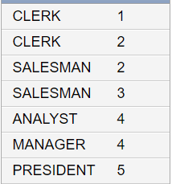

- Display the following information. (Use of Grouping Sets is not allowed)
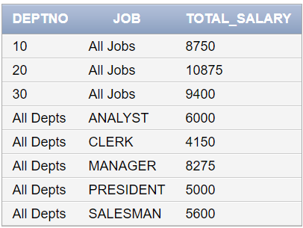
- Display the average salary for each department, along with the department name and the corresponding salary grade for that average salary.
- Find the department that has the highest average salary.
- List the employee name, job, and hire date of the 5 most recently hired employees.
- Find the second highest salary in each department.
- List all employees that earn highest salaries in each department.
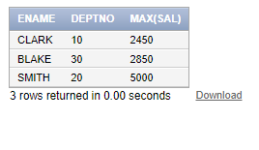
- Find employees hired in the last 6 months and whose salary is below the average salary of their

Task 03: [5 Marks]
- Retrieve the Employee Number, Department Name and Employee Number of the Manager for all those employees who work in the same department as their managers. (Use of Where clause is not allowed).
- Display the following information for employees who don’t have any subordinates. (Use of Outer Join is not allowed)
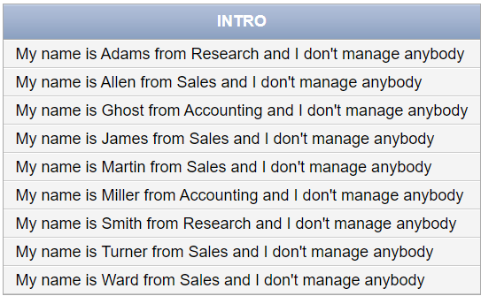

Task 04: [5 Marks]
VIVA VOCE

